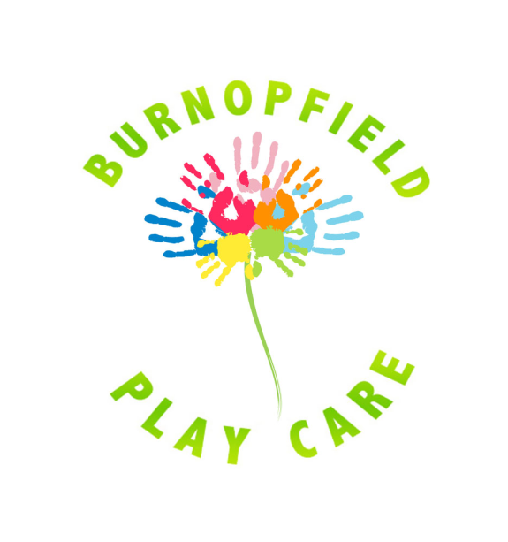
Thursday 24th August 2023
4pm – 5pm

Burnopfield Play Care

Would you like your child to come along to have lots of fun at Play Care with our professional Clown?

This is a one hour event at a cost of £3 per child. Parental supervision required if under 4 years old.
All proceeds go directly to Play Care as we are a Registered Charity.
Booking essential telephone 07914780804


For all our children already booked in for holiday care there will be no extra charge.

